Revenue Recognition
NetSuite Revenue Recognition Architecture
Advance Revenue Management (ARM) & Financial Impact
Weekly Learning Series – Week 5

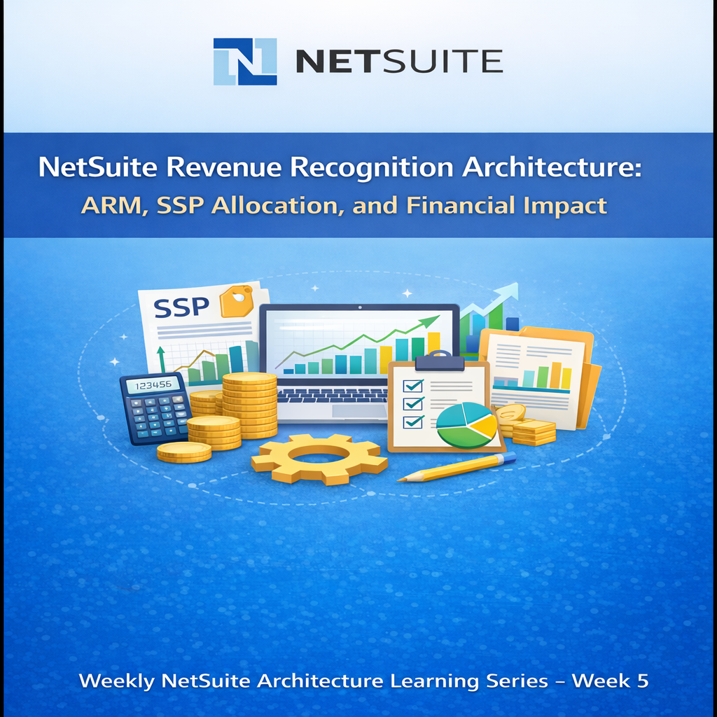

Introduction
- Revenue recognition determines when revenue is recorded in financial statements, which may differ from when a customer is billed.
- In NetSuite, billing and revenue recognition are treated as separate processes:
  - Billing defines when the customer is invoiced
  - Revenue recognition defines when income is recorded
- Revenue may be recognized:
  - Immediately at the time of invoicing, or
  - Over time based on predefined recognition schedules
- This behaviour is significantly influenced by whether Advanced Revenue Management (ARM) is enabled.
- Without ARM:
  - Revenue is typically recognized directly at the time of invoicing.
- With ARM enabled:
  - Revenue recognition is governed by structured processes including revenue elements, allocation, and revenue plans.
- Revenue recognition plays a critical role in ensuring compliance with accounting standards such as:
  - ASC 606 (United States)
  - IFRS 15 (International Financial Reporting Standards)
- These standards require revenue to be recognized based on the transfer of goods or services, not simply on billing events.
- Therefore, revenue recognition configuration in NetSuite must align with both operational billing processes and financial reporting policies.

Without ARM (Basic Revenue Recognition)
- Revenue Recognition Without ARM (Basic Model)
  - When Advanced Revenue Management (ARM) is not enabled, NetSuite uses a simplified revenue recognition approach.
- Key Characteristics:
  - Revenue is typically recognized at the time of invoicing
  - Basic revenue recognition schedules can still be applied using legacy revenue recognition templates
  - No revenue elements or revenue arrangements are created
  - No automated allocation logic exists for multi-element transactions
- Limitations:
  - Revenue is generally tied closely to billing events
  - No support for Standalone Selling Price (SSP)-based allocation
  - Difficult to accurately handle bundled or multi-component sales
  - Limited ability to comply fully with ASC 606 / IFRS 15 requirements

- Use Case:
  - This approach is suitable for simple business models where:
    - Transactions involve single deliverables
    - Revenue can be recognized immediately or in a straightforward schedule
    - Complex allocation and contract-based recognition are not required

Revenue Recognition Architecture
- Revenue recognition in NetSuite follows a layered and event-driven architecture that separates billing, allocation, planning, and financial recognition processes.
- Transaction Layer
  - Sales Orders, Invoices, Cash Sales
  - Source transactions that trigger revenue processing
- ARM Processing Layer
  - Revenue Elements (system-generated per transaction line)
  - Revenue Arrangements (grouping of related elements)
  - Allocation Engine (SSP-based allocation across elements)
- Planning Layer
  - Revenue Recognition Rules (define recognition method)
  - Revenue Plans (system-generated schedules for recognition)
- Execution Layer
  - Revenue Recognition Journal Entries
  - Recognition executed via scheduled or manual processes
- Reporting Layer
  - Financial Reports
  - Deferred Revenue Tracking
  - Revenue Plan and Forecast visibility

- Key Characteristics:
  - Revenue elements and arrangements are automatically generated upon transaction processing
  - Allocation is performed at the arrangement level using SSP logic
  - Revenue plans are created based on defined rules and contract duration
  - Revenue recognition is executed periodically based on accounting periods

This layered architecture enables NetSuite to handle complex revenue scenarios while maintaining compliance with accounting standards.

Role of Advanced Revenue Management (ARM)
- When Advanced Revenue Management (ARM) is enabled, NetSuite transforms revenue recognition from a simple billing-based process into a structured, rule-driven system.
- Instead of recognizing revenue directly at invoicing, ARM introduces a multi-step processing model:

Revenue Elements
Automatically created for each transaction line, representing individual revenue components
- Revenue Arrangements
- Group related revenue elements and act as the basis for revenue allocation
- Allocation Engine (SSP-based)
- Distributes total transaction value across elements based on Standalone Selling Price (SSP)
- Revenue Recognition Rules
- Define how and when revenue should be recognized (immediate, time-based, milestone-based)
- Revenue Plans
- System-generated schedules that determine the timing and amount of revenue recognition

Key Characteristics:
- Components are automatically generated during transaction processing
- Allocation ensures accurate distribution of revenue across multiple deliverables
- Revenue recognition is decoupled from billing and executed over time as per defined rules

ARM enables NetSuite to handle complex, multi-element transactions while ensuring compliance with ASC 606 and IFRS 15.

Revenue Allocation (SSP Concept)
- In Advanced Revenue Management, NetSuite allocates total transaction value across multiple revenue elements using Standalone Selling Price (SSP).
- This allocation is based on the relative SSP of each element and ensures compliance with ASC 606 and IFRS 15.

Key Concepts:
- Allocation is performed at the Revenue Arrangement level
- Revenue is distributed proportionally based on SSP, not actual transaction line values
- Any discount in the transaction is automatically allocated across elements using SSP ratios

Allocation Formula:
- Allocated Revenue = (Item SSP / Total SSP) × Total Transaction Amount

Example:
- Bundle Price: $1000
- SSP:
  - Item A → $800
  - Item B → $400
  - Total SSP = $1200
- Allocated Revenue:
  - Item A → (800 / 1200) × 1000 = $666
  - Item B → (400 / 1200) × 1000 = $333

This ensures that revenue is recognized based on the economic value of each component rather than the billed amount.

Revenue Recognition Rules (formerly called templates)
- In Advanced Revenue Management, Revenue Recognition Rules define how revenue should be recognized over time.
- These rules are used by the system to generate Revenue Plans, which determine the timing and amount of revenue recognition.

Recognition Methods:
- Immediate Recognition
- Revenue is recognized at the time of invoicing or fulfilment.
- Evenly Distributed Recognition
- Revenue is spread evenly across a defined time period
- Milestone-Based Recognition
- Revenue is recognized upon completion of defined milestones
- Event-Based Recognition
- Revenue is recognized based on specific triggers such as project progress or manual events

Example:
- Contract Value: $12,000
- Recognition Period: 12 months
- Monthly Revenue Recognition = $1,000

Example Financial Flow
- When deferred revenue accounting is used, the system generates the following entries:
- At Invoice Creation:
  - Dr Accounts Receivable
  - Cr Deferred Revenue
- (Revenue is not recognized immediately)
- During Revenue Recognition (Scheduled or Manual Run):
  - Dr Deferred Revenue
  - Cr Revenue
- (Revenue is recognized as per the revenue plan)

Multi-Element Revenue Example
- Scenario:
  - Software License → Immediate Recognition
  - Support Service → 12-month recognition
- System Behaviour:
- Separate revenue elements are created for each component
- Revenue is allocated (if applicable) at the arrangement level
- Individual revenue plans are generated based on assigned rules

- Accounting Impact:
- License revenue is recognized immediately
- Support revenue is deferred and recognized monthly over 12 months

- This demonstrates how NetSuite applies different revenue recognition rules within a single transaction.

Revenue Recognition Lifecycle
- The revenue recognition lifecycle in NetSuite follows a structured, event-driven sequence from transaction creation to financial reporting.
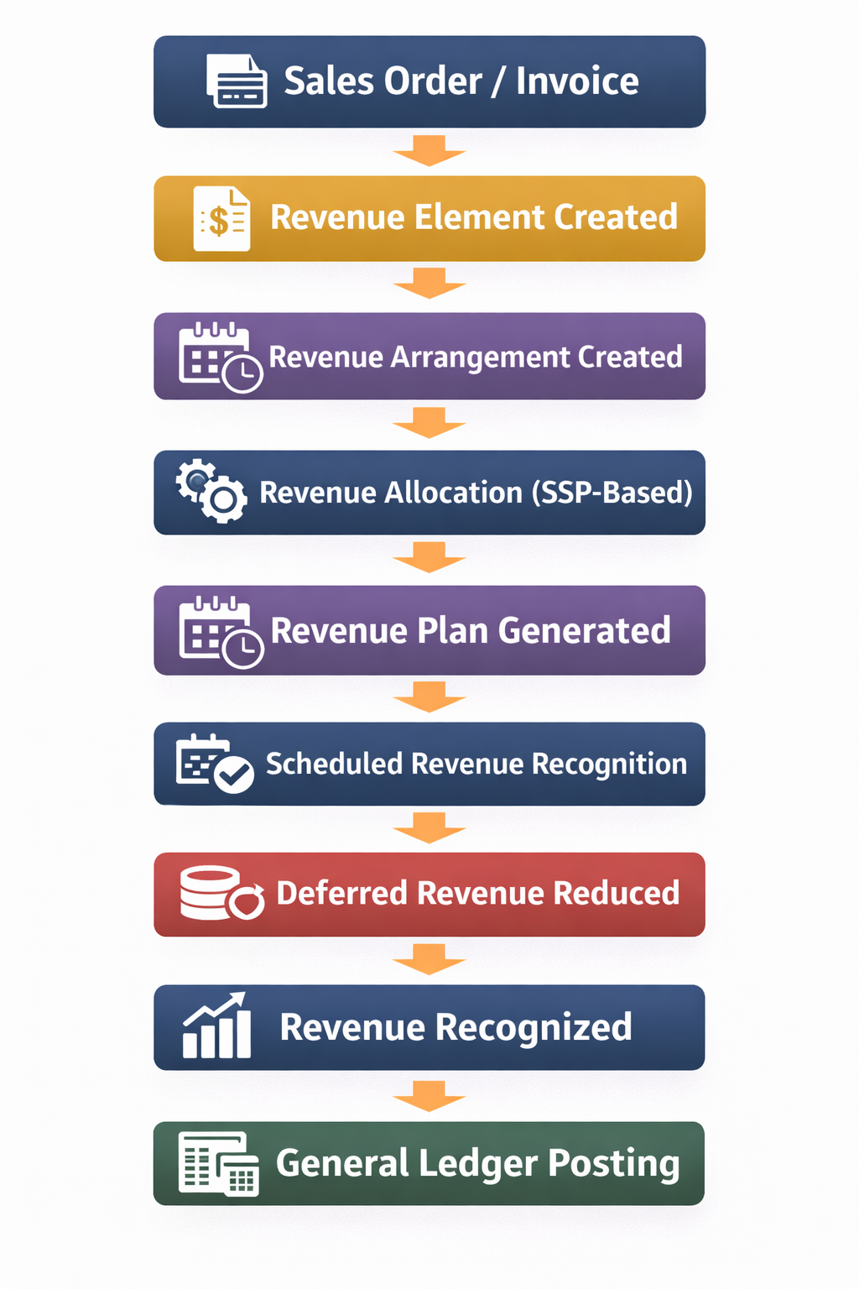

Lifecycle Steps:
  - Sales Transaction Creation
- A Sales Order, Invoice, or Cash Sale is created, initiating the revenue process.
- Revenue Element Creation
- NetSuite automatically generates revenue elements for each transaction line.
- Revenue Arrangement Creation
- Related revenue elements are grouped into a revenue arrangement.
- Revenue Allocation (SSP-Based)
- Total transaction value is allocated across elements based on Standalone Selling Price (SSP).
- Revenue Plan Generation
- Revenue plans are automatically created based on assigned revenue recognition rules.
- Revenue Recognition Execution
- Revenue is recognized periodically through scheduled or manual processes.
- Deferred Revenue Adjustment
- Deferred revenue balances are reduced as revenue is recognized.
- Revenue Recognition
- Revenue is recorded in the income statement as per the defined schedule.
- General Ledger Posting
- Journal entries are posted to reflect revenue recognition in financial reports.

- During this lifecycle, revenue is initially recorded in deferred revenue accounts (when applicable) and gradually recognized as income based on the delivery of goods or services.

Key Dependencies
- Revenue recognition behaviour in NetSuite depends on multiple interconnected configurations that influence how revenue is created, allocated, scheduled, and recognized.
Component | Impact
Item Configuration | Determines if revenue elements are created and whether ARM processing applies
Revenue Recognition Rule | Defines recognition method and drives revenue plan generation
SSP (Standalone Selling Price) | Controls allocation, discount distribution, and revenue split across elements
Revenue Arrangement | Groups elements and acts as the basis for allocation
Accounting Period | Controls when revenue can be recognized
Contract / Rev Rec Dates | Define start and end of revenue recognition schedule
Billing Structure | Influences timing and structure of revenue generation
Revenue Recognition Process | Required to execute and post revenue recognition entries

- Note: Changes in any of these components directly impact revenue timing, allocation, and financial reporting outcomes.

Risks and Misconfiguration
- Incorrect configuration of revenue recognition in NetSuite can lead to significant financial reporting issues and compliance risks.
Common Risks:
  - Incorrect Revenue Timing
- Revenue may be recognized too early or too late due to improper revenue recognition rules or incorrect start/end dates.
  - Incorrect Deferred Revenue Balances
- Misconfigured accounts or recognition schedules can result in inaccurate deferred revenue postings.
  - Misalignment with Contract Obligations
- Revenue recognition may not reflect actual delivery of goods or services, leading to non-compliance with ASC 606 / IFRS 15.
  - Incorrect Revenue Allocation
- Missing or incorrect SSP values can cause improper allocation across bundled items.
  - Revenue Plan Issues
- Revenue plans may not be generated or may be generated incorrectly due to configuration gaps.
Execution Failures
- Revenue may not be recognized if the revenue recognition process is not executed or scheduled properly.
Root Causes:
- Incorrect item configuration or missing revenue rules
- Missing or inaccurate SSP values
- Incorrect contract or revenue recognition dates
- Improper accounting period setup
- Failure to run revenue recognition processes
Impact:
- These issues can lead to:
- Financial misstatements
- Incorrect profit reporting
- Audit findings and compliance issues
- Manual adjustments and rework during financial close

Real Project Risk Example
Scenario:
- In one implementation involving bundled sales (software license + support services), incorrect SSP configuration led to improper revenue allocation across revenue elements.
Impact:
- Revenue was over-recognized in initial periods due to incorrect allocation ratios
- Deferred revenue balances were understated
- Financial reports did not accurately reflect revenue distribution
- Audit issues were raised during financial review
Root Cause:
- SSP values were missing or incorrectly defined for bundled items
- Incorrect SSP setup caused disproportionate allocation during revenue arrangement processing
- Allocation logic did not reflect actual standalone selling prices
Resolution:
- SSP values were corrected for all affected items
- Revenue arrangements were reprocessed to trigger correct allocation
- Revenue plans were regenerated based on updated allocation
- Incorrectly recognized revenue was adjusted through corrective journal entries
Outcome:
- Revenue allocation aligned with SSP-based logic
- Deferred and recognized revenue balances were corrected
- Financial reporting compliance was restored

Governance Controls
- Organizations should implement strong governance controls to ensure accurate and compliant revenue recognition in NetSuite.
Recommended Controls:
  - Preventive Controls:
- Finance approval for revenue recognition rules and SSP configurations
- Restricted access to modify item configuration, SSP, and revenue rules
- Validation of contract terms against revenue recognition setup before transaction processing
  - Detective Controls:
- Periodic review of deferred revenue balances and recognized revenue
- Monitoring of revenue plans generated by ARM for accuracy
- Reconciliation between billing, revenue arrangements, and financial reports
  - Process Controls:
- Alignment between contract terms and revenue recognition schedules
- Regular review of SSP values for accuracy and completeness
- Validation of revenue allocation for bundled transactions
  - Execution Controls:
- Ensure revenue recognition processes are scheduled and executed consistently
- Review system-generated journal entries for correctness during period close

These controls help prevent misstatements, ensure compliance with ASC 606 / IFRS 15, and reduce risk during financial audits.

Decision Logic for Revenue Recognition
- Selecting the appropriate revenue recognition method in NetSuite depends on how and when the performance obligation is fulfilled.
Recognition Methods and Decision Criteria:
  - Immediate Recognition
- Used when the performance obligation is satisfied at a single point in time.
- Applicable for:
  - One-time product sales
  - Services delivered instantly
- Trigger Condition:
  - Control of goods or services is transferred immediately
- Time-Based Recognition
- Used when the performance obligation is satisfied over a period of time.
- Applicable for:
  - Subscriptions
  - Support or maintenance contracts
  - Long-term service agreements
- Trigger Condition:
  - Revenue is recognized progressively over the contract duration
- Milestone-Based Recognition
- Used when revenue is tied to specific deliverables or project milestones.
- Applicable for:
  - Project-based billing
  - Implementation or development services
- Trigger Condition:
  - Revenue is recognized upon completion of defined milestones
- System Application in NetSuite:
- These methods are configured using Revenue Recognition Rules
- Revenue Plans are generated based on the selected method
- Recognition is executed according to defined schedules or events

Selecting the correct method ensures that revenue is recognized in alignment with the delivery of goods or services, supporting accurate financial reporting and compliance with ASC 606 / IFRS 15.

Architectural Insight
- Revenue recognition in NetSuite is fundamentally designed to decouple billing events from financial revenue realization.
- While billing determines when a customer is invoiced, revenue recognition determines when revenue is earned based on the fulfillment of performance obligations.
- This separation is achieved through Advanced Revenue Management (ARM), which introduces an intermediate processing layer:
- Revenue Elements represent individual revenue components
- Revenue Arrangements group and allocate revenue across elements
- SSP-based allocation ensures fair distribution of transaction value
- Revenue Plans control the timing of recognition
- This architecture allows NetSuite to handle complex, multi-element transactions where multiple goods or services are delivered at different times.

As a result:
- Billing can occur upfront or at various stages
- Revenue can be recognized immediately or over time, independent of billing

This design ensures that financial reporting reflects the actual delivery of value rather than cash flow or invoicing events.

- When properly implemented, this architecture provides:
- Accurate revenue timing
- Compliance with ASC 606 / IFRS 15
- Transparency in deferred and recognized revenue

Ultimately, revenue recognition in NetSuite is not just a feature, but a structured system that translates business transactions into compliant financial outcomes.

